We’ve been “Back Together Again”,
now it’s time for FASFAA to Assemble
Moving from 2021-22 to 2022-23 (June 20 – June 21, 2022)
Embassy Suites USF
3705 Spectrum Blvd.
Tampa, FL 33612

Transition Meeting Agenda

Microsoft Teams meeting
Join on your computer or mobile app
Click here to join the meeting
Or call in (audio only)
+1 904-647-1241,,865245985# United States, Jacksonville
(866) 781-1385,,865245985# United States (Toll-free)
Phone Conference ID: 865 245 985#
Monday, June 20, 2022 – 2021-22 Board (Outgoing Board) with 2022-23 Board (Incoming Board) Observing
10:00 am Meeting Convenes
10:10 am Welcome and New Board Introductions: Katie & Nadine
10:25 am Old Business: Review of Financial Condition: Eileen Brzozowski
10:55 am New Business
11:15 am Committee Year-End Reports/One Success (Only review if written report has been changed)
12:00 pm Lunch Break
1:00 pm Team Building
2:00 p.m. Outgoing Board Suggestions for Next Year
3:15 pm Incoming Board Meets with Outgoing Board
3:55 pm Passing of the Gavel
4:00 pm Old Board Adjournment
5:00 pm Complimentary Evening Reception (provided by hotel)
6:45 pm Dinner (TBD)

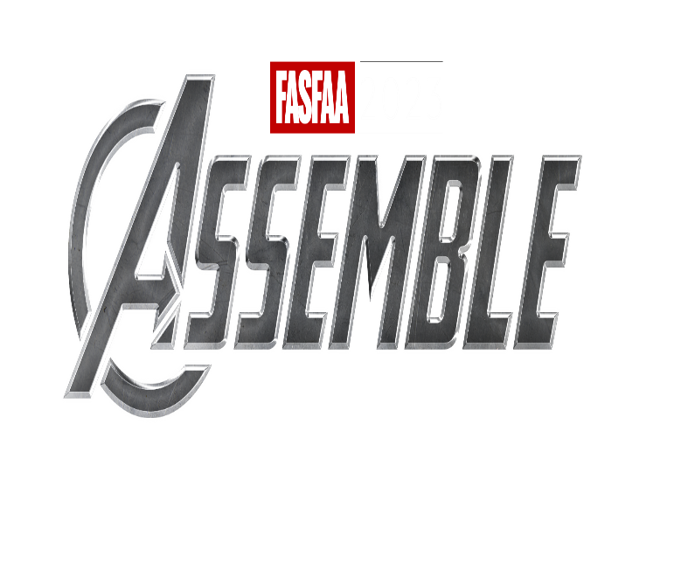
Microsoft Teams meeting
Join on your computer or mobile app
Click here to join the meeting
Or call in (audio only)
+1 904-647-1241,,865245985# United States, Jacksonville
(866) 781-1385,,865245985# United States (Toll-free)
Phone Conference ID: 865 245 985#

Tuesday June 21st –2022-23 Board (Incoming Board)
7:00 am Breakfast for those that stay at the hotel (provided by the hotel)
9:00 am Call to Order: Nadine Bailey
9:05 am Welcome and Board Installation: Nadine Bailey
9:15 am New Business: Nadine Bailey & Kris Hatcher
9:45 am FASFAA Goals and Expectations for 2022-23: Nadine Bailey
10:15 am FASFAA OneDrive: Ang Parrales
10:30 am FASFAA Governing Documents (Bylaws, P&P, Diversity Statement, Strategic Plan): Joan Bailey
11:45 am Break for lunch
1:00 pm Parliamentary Procedure: Wayne Kruger
2:00 pm Budget Planning and Finance Committee: Katie Conrad
2:45 pm Logistics, Expense Reports, Future Meeting Schedule: Gwyn Francis & Nadine Bailey
3:00 pm Adjournment

SAFE TRAVELS

