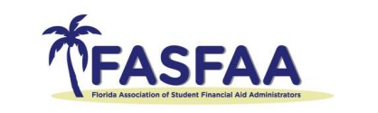

2025 Bonnie Pirkle Scholarship Recipients

President – Santa Fe College – Mia Mwango
Tracy Henley $1,666.66
Ana Abouzid $1,666.66
Callie Merrill $1,666.66
Secretary – Valencia College – Susan Ambridge
Nichole Zevallos $611.00
Victoria Otero $611.00
Treasurer – Florida Atlantic University – Chrissy Gass
Marguerite Hope $611.00
Treasurer-Elect – University of Central Florida – Sedrick Brinson
Dwartney Wortham Jr. $611.00
Region I Representative – Pensacola State College – Angelica Coonts
Barbara “Barbie” Hackson $611.00
Region II Representative – University of Florida– Marie Guerra Rosado
N/A $611.00
Region III Representative – University of Central Florida – Karissa Lawson
Melanie Ramos Melendez $611.00
Region IV Representative – Florida Polytechnic University – Carrie Mann
Joel Melendez $611.00
Region V Representative – University of Miami – Joseph Gonzalez
Menachem Coen $611.00

